**Lab 4: Implement 0/1 Knapsack Problem using greedy approach.**

**Code:**

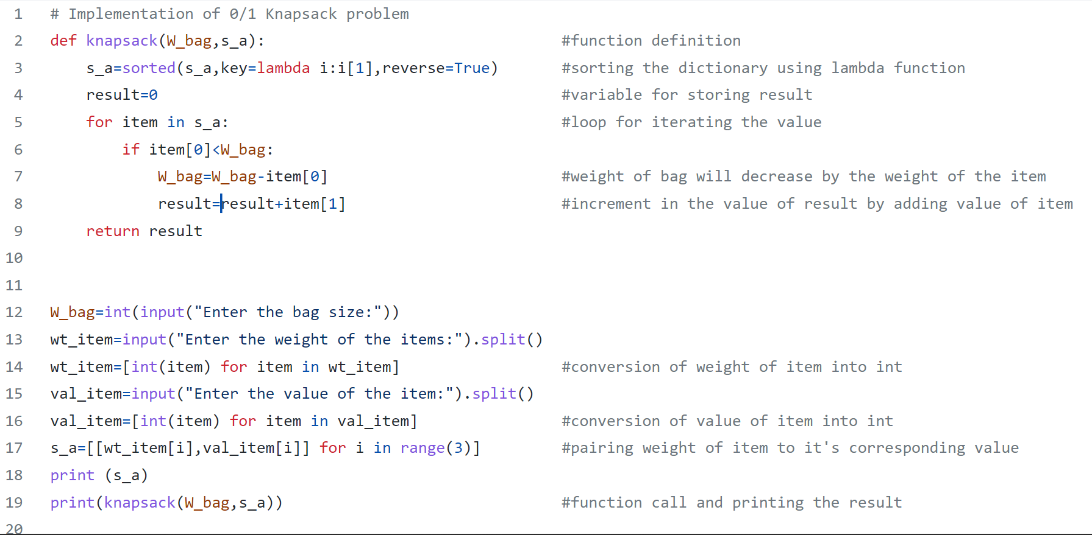

**Terminal:**

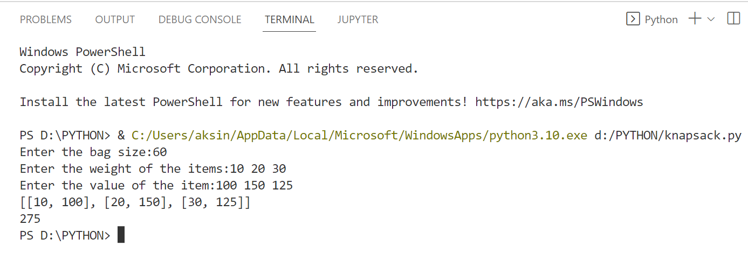

**GitHub:** https://github.com/Atul202072/ADA/blob/main/knapsack.py